

WEEK 2, T2 - 2015
Score ( x / 15 ) | %

LAKELAND SHS MATHEMATICS

MATHEMATICS METHODS
test 2 – Part a

NAME: ______________________________ Time allowed: 15 min

CALCULATOR FREE AND NOTE FREE SECTION

Q1 Factorise these expressions: [4 marks]
- d² + 14d + 24

- b² + 6b - 40

Q2 Expand and simplify (5x + 2)(3x² + 2x – 2) [3 marks]

Q3 Given that (x + 1) is a factor, solve the equation x³ – 5x² + 2x + 8 = 0. [5 marks]

Q4 [3 marks]

Use the quadratic formula or otherwise to solve 3x² – 2x – 5 = 0 and write your answers correct to 3 significant figures where appropriate.

WEEK 2, T2 - 2015
Score ( x / 40 ) | %

LAKELAND SHS MATHEMATICS

MATHEMATICS METHODS
test 1 – Part B

NAME: ______________________________ Time allowed: 55 min

CALCULATOR AND NOTES ASSUMED

Q1 If P(x) = 2x⁴ + 4x³ + 2x² – 5x – 8, find P(4) [2 marks]

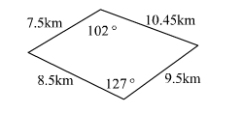
Q2 Calculate this area correct to 1 decimal place. [6 marks]

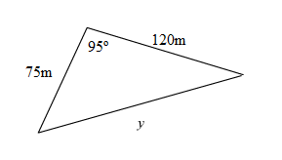
Q3 Find the length y. Round your answer to the nearest whole number. [3 marks]

Q4 [4,8,2 = 14 marks]

Each of the following functions is sketched below, where a, b, c, d, e, h, i and j are constants.

(i) y = a(x + b)³ + c (ii) y = (x + d)² + e
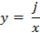
(iii) y = h(x + 2)(x + i)² (iv)

a) Match each of the graphs, A,B,C and D with its corresponding function, by completing the table below.
(i) | (ii) | (iii) | (iv)

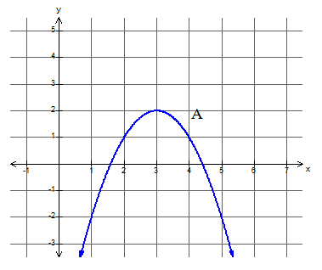
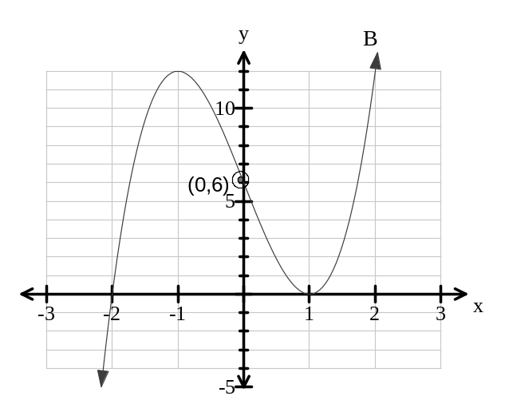
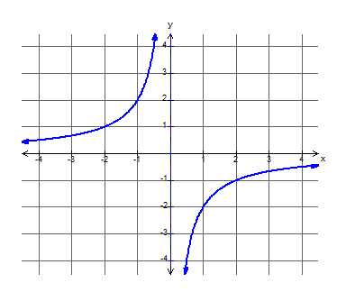
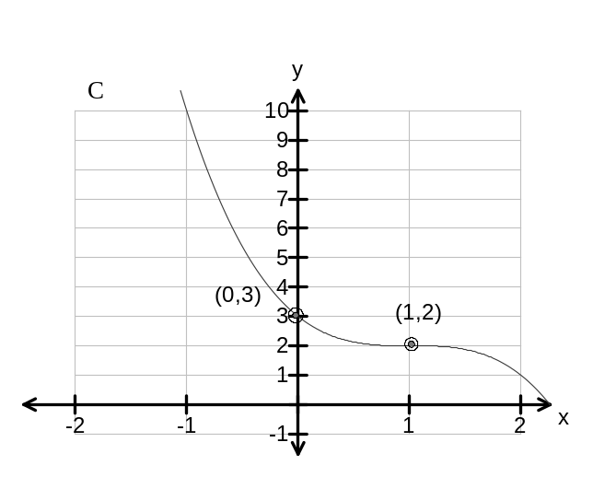
D

b) Use the graphs and equations of the functions to determine the values
of a, b, c, d, e, h, i and j. Show working.

c) Explain what an asymptote is OR say which graph above has asymptote(s) and state its equation(s).

Q5 Draw a sketch of the circle with the equation (x – 6)² + (y + 5)² = 16. [6 marks]
Use your graph or otherwise, to find the domain and range.

Q6. [2 marks]
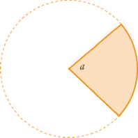
Find the area of the shaded shape below if the radius of the circle is 40cm and angle a isradians. Round your answer to the nearest whole number if necessary.

Q7. [5 marks]

The curve 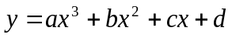 has intercepts at (1, 0), (4, 0), (-2, 0) and (0, 24).

Find the values of a, b, c and d.

Q8. [2 marks]

4 teachers take 9 hours to mark the Year 11 Integrated Science exam for all students at Swampland SHS. Assuming that all teachers mark papers at a similar speed, how long will it take 3 teachers to mark the papers?

